Aim – Delete Document in database.

Learning outcome: Able to configure embedded databases with different web pages using MongoDB.

Duration: 1 hours

List of Hardware/Software requirements:

1. Laptop/Computer with Linux OS - Ubuntu 18.04 LTS
2. MongoDB 6.0.5 Community Edition

**Follow the below step’s**

We have already had a database which name is pglu. we create this database on activity 1.

Step 1: **use pglu** (This is use for choose database which you want to insert values.

Step 2: db.Emp.InsertOne({name:”Anita”, salary: 15000}). (This cmd is to insert a value into the collection and here is Emp is Collection)

**Output:**

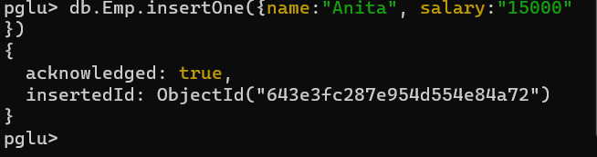

**Delete cmd**

* **deleteOne**

Step 3: db.Emp.deleteone({name:”Deepak elu”}) (This cmd is use for delete fields. There have to type pf delete deleteOne and deleteMany. If you want to delete Many fields then ypou can go with deleteMany)

**Input:**

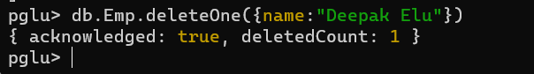

* **deleteMany**

Step 4: **db.Emp.insertMany([{name:"Aarti",salary:15000},{name:"Aarti",salary:15000},{}])** and enter (This cmd use to insert many values into the database see the below image).

**Input:**

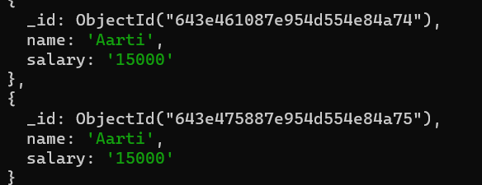

Step 5: db.Emp.deleteMany({name:"Aarti"})

**Output:**

